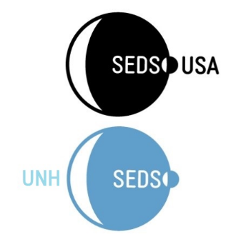

UNH SEDS

8 College Road- Room S172

Durham, NH 03824

10/09/2017

My name is Charlie Nitschelm, co-founder and president of the UNH chapter of Students for the Exploration and Development of Space (SEDS). SEDS pursues its mission by educating students about the benefits of space, by supporting a network of interested students, and inspiring people through our involvement in space-related projects. SEDS believes that humanity's future is in space and that focusing the enthusiasm of young people is the key to our future in space.

Comprised of students from all disciplines, UNH SEDS is beginning to take shape. Although founded a mere 7 months ago in February of 2017, we have our goals clearly outlined. SEDS USA provides many resources for us to pursue our overarching goal in providing students an experience with running an organization, outreach and engineering design. There are over 50 SEDS chapters nationwide, each vastly different from the other. Some focus on networking, others in engineering. UNH SEDS has become dedicated to learning about the cosmos in addition to pushing the bounds of our members to design, manufacture and build projects relating to the exploration of space. This year, we have chosen to build a two-stage high altitude rocket to compete in a USA SEDS competition next September. The few projects we would like to complete after this school year includes a high-altitude weather balloon and the first stages of designing a CubeSat (called CubeCat of course!) This satellite, which will perform one function will be able to get launched into space by our friends at NASA!

Of course, to accomplish these goals, two things are needed. The first comes in boat loads: dedication and enthusiasm. The students who have joined this organization with me carry the same attitude I have. It is why I started this club in the first place! With this dedication, we can learn what we need to know to design, manufacture and build the best products we can. The second is vastly scarce, and I am sure you are already aware of what this is: money. Although some of us pay over $50,000 to study at UNH, we are somehow always in need of more money. This letter is the start of us reaching out to companies like you; to help support us in learning as much hands on designing, engineering, manufacturing and testing we can. As of now, being comprised of mostly underclassmen, there is tremendous growth heading our way. Any support would be greatly appreciated. If you have any questions regarding sponsorship or the organization in general, feel free to reach out to me at the contact information provided below. We can provide a sponsorship packet if interested!

Regards,

Charlie Nitschelm

Co-Founder and President

UNH SEDS

[Pool.UNHSEDS01p@unh.edu](mailto:Pool.UNHSEDS01p@unh.edu)

1-603-923-9079